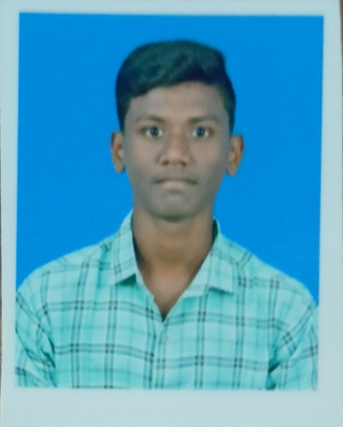 **RESUME**

**S.SEBASTIN,**

**S/O, S. Savariyappan,**

**Nerkuppai,**

**Pottavelikkalam, Email-ID :** [**joyalsebastin466@gmail.com**](joyalsebastin466@gmail.com)

**Sivaganga(Dt)-630 405. Phone No : 9025883716**

**ACADEMIC PERFORMANCE**

* **HIGHER EDUCATION**

Awarded with 72.1% marks in Sathappa Government Hr Sec School.

**SKILLS**

* **MS office.**
* **C, JAVA, PHP, Programming Languages.**
* **HTML , CSS, JavaScript Scripting Languages.**
* **VB.NET**
* **PYTHON**
* **PHOTO & VIDEO EDITING**

**PERSONAL DETAILS**

**NAME : S.SEBASTIN**

**FATHER NAME : S.SAVARIYAPPAN**

**MOTHER NAME : S.DAISY**

**D.O.B : 21/11/2004**

**BLOOD GROUP : A+**

**AGE : 19**

**RELIGION : CHRISTIAN**

**NATIONALITY : INDIAN**

**LANGUAGE KNOWN : TAMIL, ENGLISH**

**MARTIAL STATUS : UN MARRIED**

**DECLARATION**

I hereby declare that the above given details are true to the best of my knowledge.

Yours Faithfully,

S.Sebastin